|  |
| --- |
|  |
| Capstone Project Document |

**VIETNAMESE MEDICINE NETWORK**

Report #2 – Screen Design

|  |  |  |
| --- | --- | --- |
| **Dandelion** | | |
| **Group Members** |  | SE02585 |
|  | SE02619 |
|  | SE02723 |
|  | SE02700 |
| **Supervisor** | Mr. Nguyễn Văn Sang | |
| **Project code** | VMN | |

**- Hanoi, 09/2015 -**

# SIGNATURE PAGE

AUTHOR: Vũ Công Chính 28/09/2015

Team member

REVIEWERS: Lưu Ngọc Mạnh 30/09/2015

Project manager

APPROVAL: Nguyễn Văn Sang --/--/--15

Supervisor

Record of change

*A - Added M - Modified D – Deleted

|  |  |  |  |  |  |
| --- | --- | --- | --- | --- | --- |
| Effective Date | Changed Item | A,M,D | Change Description | Reason for Change | Rev. Number |
| 28/Sep/2015 | Create Screen Design | A | First version | Create Screen Design | 1.0 |
|  |  |  |  |  |  |
|  |  |  |  |  |  |
|  |  |  |  |  |  |
|  |  |  |  |  |  |
|  |  |  |  |  |  |
|  |  |  |  |  |  |

Table of Contents

SIGNATURE PAGE 0

Introduction 3

1.1 Purpose 3

1.2 Definitions, Acronyms and Abbreviations 3

1.3 Overview 3

2 Screen flow 4

2.1 Register 5

2.2 Login 6

2.3 Search project 7

2.4 Discover 9

2.5 Create project 10

2.6 Edit project 12

2.6.1 Basic tab 12

2.6.2 Reward tab 13

2.6.3 Story tab 15

2.6.4 Update tab 16

2.6.5 Question and Answer tab 18

2.7 Statistic 20

2.8 Project detail 22

2.8.1 Information tab 23

2.8.2 Update tab 25

2.8.3 Comment tab 25

2.9 Back project 26

2.9.1 Back project 26

2.9.2 Payment project 27

2.10 Message 28

2.10.1 Sent message 29

2.10.2 Delete message 30

2.10.3 Message view 31

2.11 Project management 32

2.11.1 Created project 32

2.11.2 List backer project 33

2.11.3 Backed project 34

2.11.4 Starred project 35

2.12 Account management 36

2.12.1 Account 36

2.12.2 Edit profile 37

2.12.3 Public profile 38

2.13 ADMIN 39

2.13.1 Login 40

2.13.2 Dashboard 41

2.13.3 Users 43

2.13.4 Projects 47

2.13.5 Backing 50

2.13.6 Category 51

2.13.7 Slider 53

2.13.8 Message (same as message of user) 55

2.13.9 Report 56

# Introduction

## Purpose

To ensure consistency and simplicity in detailed design across all displays within a product interface, as well as across other products used by the same users. Definitions, acronyms, abbreviations, references and overview of DDL website.

## Definitions, Acronyms and Abbreviations

|  |  |  |
| --- | --- | --- |
| Abbreviations | Description | Comment |
| DDL | Dandelion |  |
| Q&A | Question and Answer |  |

1. Definitions, Acronyms and Abbreviations

## Overview

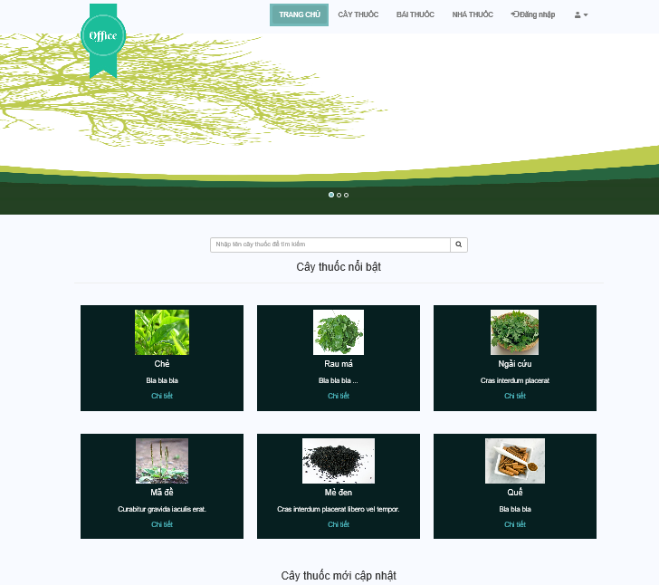

# Screen flow

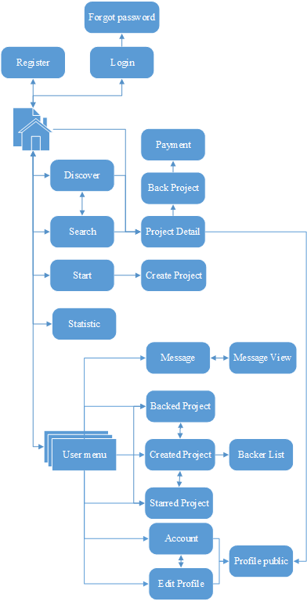

1. Client screen flow

## Register

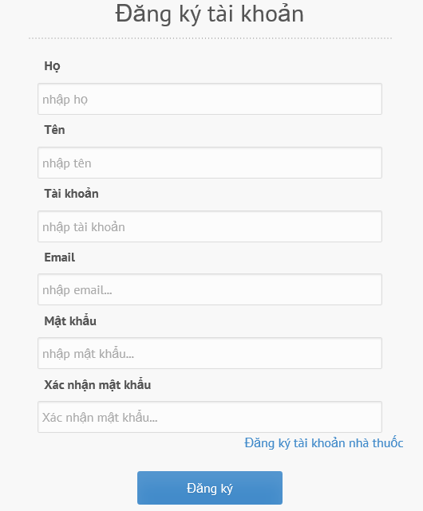

1. R**egister screen**

|  |  |  |  |  |  |  |  |
| --- | --- | --- | --- | --- | --- | --- | --- |
| No | Field name | Field name in Vietnamese | Type | Require | Mandatory | Max-Length | Description |
|  | Register | Đăng ký | Label |  | Y |  | Display register form |
|  | Last name | Họ | Textbox | Type | Y | 8-20 | Last name of user |
|  | First name | Tên | Textbox | Type | Y | 8-20 | First name of user |
|  | Username | Tên tài khoản | Textbox | Type | Y | 8-20 | Username of user |
|  | Email | Email | Textbox | Type | Y |  | Email of user |
|  | Password | Mật khẩu | Textbox | Type | Y | 8-50 | Password of user |
|  | Confirm Password | Nhập lại mật khẩu | Textbox | Type | Y |  | User retype password |
|  | Register as Herb Medicine Store | Đăng ký tài khoản nhà thuốc | Hyperlink | Click | Y |  | User register a new Herb Medicine Store account |
|  | Sign up | Đăng ký | Button | Click | Y |  | User register a new account |

1. R**egister** screen

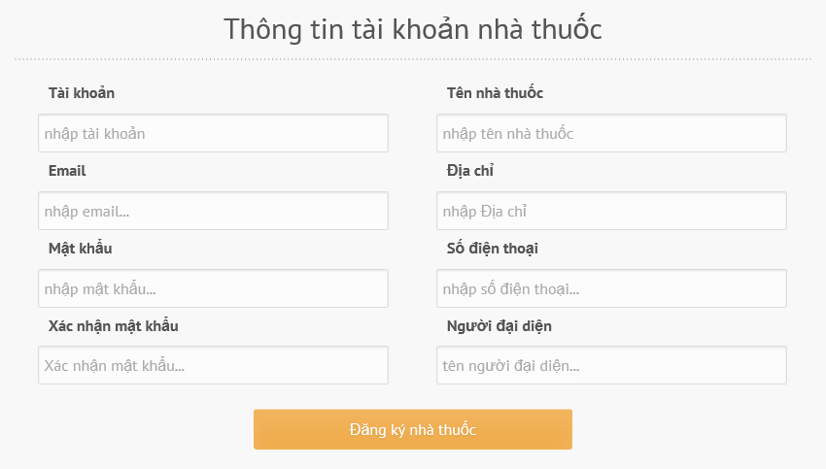

|  |  |  |  |  |  |  |  |
| --- | --- | --- | --- | --- | --- | --- | --- |
| No | Field name | Field name in Vietnamese | Type | Require | Mandatory | Max-Length | Description |
|  | Register as herb medicine store | Đăng ký | Label |  | Y |  | Display register form |
|  | Name of herb medicine store | Họ | Textbox | Type | Y | 8-20 | Last name of user |
|  | Username | Tên tài khoản | Textbox | Type | Y | 8-20 | Username of user |
|  | Email | Email | Textbox | Type | Y | 8-20 | Email of user |
|  | Password | Mật khẩu | Textbox | Type | Y | 8-20 | Password of user |
|  | Confirm Password | Nhập lại mật khẩu | Textbox | Type | Y | 8-20 | User retype password |
|  | Address | Địa chỉ | Textbox | Type | Y | 8-50 | Drugstore address |
|  | Phone | Điện thoại | Textbox | Type | Y | 8-20 |  |
|  | Representative | Người đại diện | Textbox | Type | Y | 8-20 |  |
|  | Sign up | Đăng ký | Button | Click | Y |  | User register a new account |

## Login

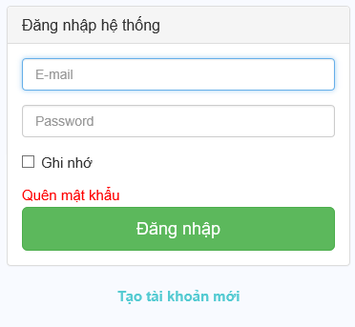

1. Login **screen**

|  |  |  |  |  |  |  |  |
| --- | --- | --- | --- | --- | --- | --- | --- |
| No | Field name | Field name in Vietnamese | Type | Require | Mandatory | Max-Length | Description |
|  | Login | Đăng nhập | Label | Type | Y |  |  |
|  | Email | Email | Textbox | Type | Y |  | Email of registered user |
|  | Password | Mật khẩu | Textbox | Type | Y |  | Password of registered user |
|  | Remember Me | Lưu đăng nhập | Check box | Click | Y |  | Save login information |
|  | Forgot Password | Quên mật khẩu | Hyper link | Click | Y |  | Resend password to user |
|  | Login | Đăng nhập | Button | Click | Y |  | Login |
|  | Register now | Đăng ký ngay | Hyper link | Click | Y |  | Register when user have not an account |

1. Loginscreen

## Search

### Basic Search



|  |  |  |  |  |  |  |  |
| --- | --- | --- | --- | --- | --- | --- | --- |
| No | Field name | Field name in Vietnamese | Type | Require | Mandatory | Max-Length | Description |
| 1. 1 | Search box | Ô tìm kiếm | Text | Type | Y | 20 | Search by medicinal plant key word |
| 1. 2 | Search icon | Hình tìm kiếm | Button | Click | Y |  | Click to search medicinal plant |

### Advance Search Medicine Plant Article

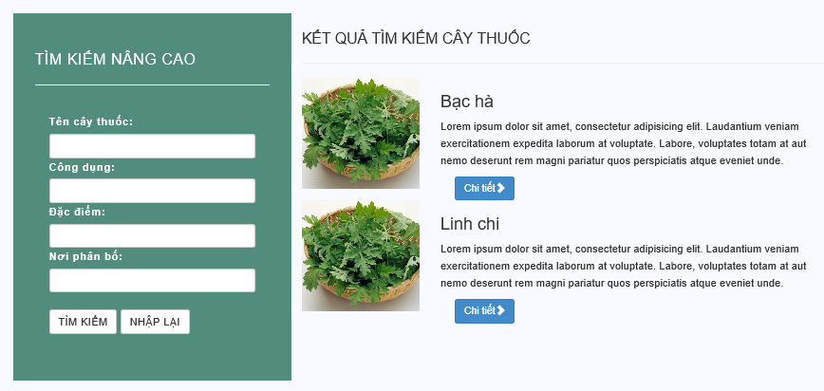

|  |  |  |  |  |  |  |  |
| --- | --- | --- | --- | --- | --- | --- | --- |
| No | Field name | Field name in Vietnamese | Type | Require | Mandatory | Max-Length | Description |
| 1. 1 | Advance search | Tìm kiếm nâng cao | Label |  | Y |  | Display text |
|  | Medicinal plant | Tên cây thuốc | Text | Type | Y | 20 | User type medicinal plant name |
|  | Utility | Công dụng | Text | Type | Y | 20 | User type utility |
|  | Characteristic | Đặc điểm | Text | Type | Y | 20 | User type characteristic |
|  | Allocation place | Nơi phân bố | Text | Type | Y | 20 | User type allocation place of medicinal plant |
|  | Search | Tìm kiếm | Button | Click | Y |  | Click to search medicinal plant |
|  | Reset | Nhập lại | Button | Click | Y |  | Click to reset all text area |
|  | Result | Kết quả tìm kiếm cây thuốc | Label |  | Y |  | Display text |
|  | Medicinal plant list | Danh sách cây thuốc |  |  | Y |  | Show medicinal plant list |

### Advance Search Remedy Article

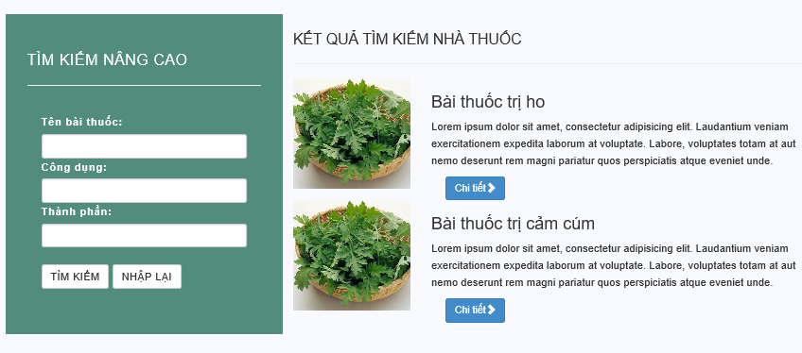

|  |  |  |  |  |  |  |  |
| --- | --- | --- | --- | --- | --- | --- | --- |
| No | Field name | Field name in Vietnamese | Type | Require | Mandatory | Max-Length | Description |
| 1. 1 | Advance search | Tìm kiếm nâng cao | Label |  | Y |  | Display text |
|  | Remedy | Tên bài thuốc | Text | Type | Y | 20 | User type remedy name |
|  | Utility | Công dụng | Text | Type | Y | 20 | User type utility |
|  | Element | Đặc điểm | Text | Type | Y | 20 | User type element |
|  | Search | Tìm kiếm | Button | Click | Y |  | Click to search remedy |
|  | Reset | Nhập lại | Button | Click | Y |  | Click to reset all text area |
|  | Result | Kết quả tìm kiếm bài thuốc | Label |  | Y |  | Display text |
|  | Remedy list | Danh sách bài thuốc |  |  | Y |  | Show remedy list |

## Medicinal Plant

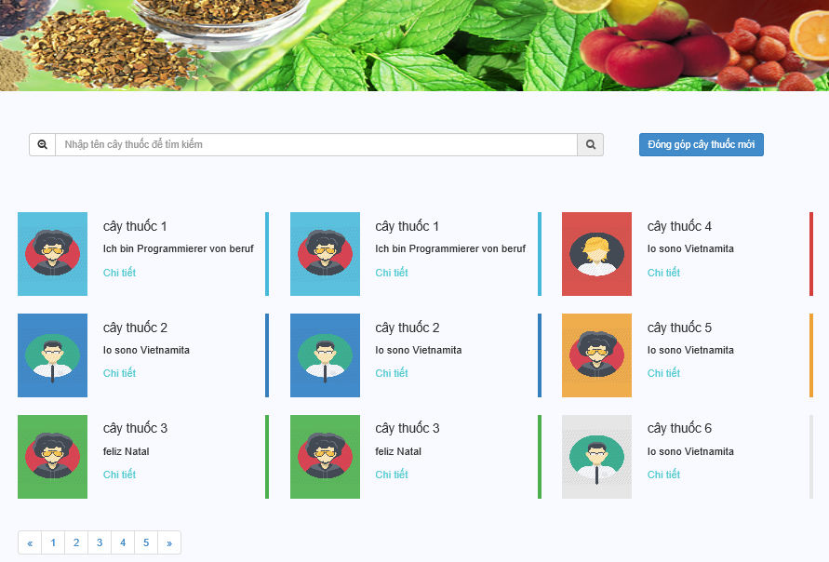

|  |  |  |  |  |  |  |  |
| --- | --- | --- | --- | --- | --- | --- | --- |
| No | Field name | Field name in Vietnamese | Type | Require | Mandatory | Max-Length | Description |
| 1. | Banner | Quảng cáo | Picture |  | Y |  |  |
| 2. | Search | Text field | Text field | Type | Y | 8-20 |  |
| 3. | Contribute remedy | Đóng góp cây thuốc | Button | Click | Y |  | User click to contribute new remedy article |
| 4. | Remedy list | Danh sách cây thuốc | Text |  | Y |  | Show remedy list |
| 5. | Detail | Chi tiết | Hypertext link | Click | Y |  | Show a remedy article detail |
| 6. | Paging bar | Thanh đánh số trang |  | Click | Y |  |  |

## Remedy

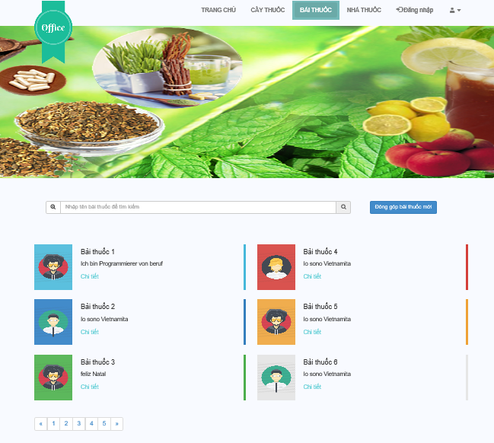

|  |  |  |  |  |  |  |  |
| --- | --- | --- | --- | --- | --- | --- | --- |
| No | Field name | Field name in Vietnamese | Type | Require | Mandatory | Max-Length | Description |
| 1. | Banner | Quảng cáo | Picture |  | Y |  |  |
| 2. | Search | Text field | Text field | Type | Y | 8-20 |  |
| 3. | Contribute remedy | Đóng góp bài thuốc | Button | Click | Y |  | User click to contribute new remedy article |
| 4. | Remedy list | Danh sách bài thuốc | Text |  | Y |  | Show remedy list |
| 5. | Detail | Chi tiết | Hypertext link | Click | Y |  | Show a remedy article detail |
| 6. | Paging bar | Thanh đánh số trang |  | Click | Y |  |  |

## Herb Medicine Store

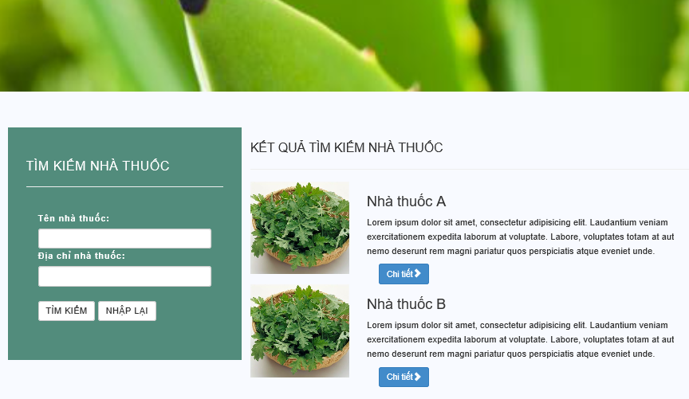

|  |  |  |  |  |  |  |  |
| --- | --- | --- | --- | --- | --- | --- | --- |
| No | Field name | Field name in Vietnamese | Type | Require | Mandatory | Max-Length | Description |
| 1. 1 | Advance search | Tìm kiếm nâng cao | Label |  | Y |  | Display text |
|  | Herb medicine store | Tên bài thuốc | Text | Type | Y | 20 | User type remedy name |
|  | Address | Công dụng | Text | Type | Y | 20 | User type utility |
|  | Element | Đặc điểm | Text | Type | Y | 20 | User type element |
|  | Search | Tìm kiếm | Button | Click | Y |  | Click to search remedy |
|  | Reset | Nhập lại | Button | Click | Y |  | Click to reset all text area |
|  | Result | Kết quả tìm kiếm bài thuốc | Label |  | Y |  | Display text |
|  | Remedy list | Danh sách nhà thuốc |  |  | Y |  | Show remedy list |

## Contribute new article

### Contribute new medicinal plant article

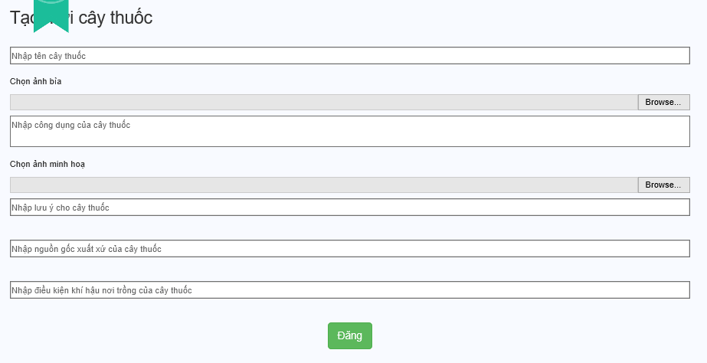

|  |  |  |  |  |  |  |  |
| --- | --- | --- | --- | --- | --- | --- | --- |
| No | Field name | Field name in Vietnamese | Type | Require | Mandatory | Max-Length | Description |
|  | Create new medicinal plant | Tạo mới cây thuốc | Label |  | Y |  | Display text |
|  | Medicinal plant | Tên cây thuốc | Text | Type | Y | 20 | Medicinal plant name |
|  | Other name | Tên khác | Text | Type | Y | 200 |  |
|  | Science name | Tên khoa học | Text | Type | Y | 200 |  |
|  | Choose backgroud | Chọn ảnh bìa | Button | Click | Y |  | Image of medicinal plant |
|  | Utility | Công dụng của cây thuốc | Text | Type | Y | 500 | Công dụng của cây thuốc |
|  | Choose example picture | Chọn ảnh minh họa | Button | Click | Y |  | Ảnh minh họa của cây thuốc |
|  | Note for medicinal plant | Nhập lưu ý cho cây thuốc | Text | Type | Y | 500 | Lưu ý cho cây thuốc |
|  | Allocation place | Nhập nguồn gốc xuất xứ cho cây thuốc | Text | Type | Y | 200 | Nguồn gốc, xuất xứ của cây thuốc |
|  | Climatic condition of medicinal plant | Nhập điều kiện khí hậu nơi trồng cây thuốc | Text | Type | Y | 200 | điều kiện khí hậu, nơi trồng cây thuốc |
|  | Post | Đăng | Button | Click | Y |  | Đăng cây thuốc |

### Contribute new remedy article

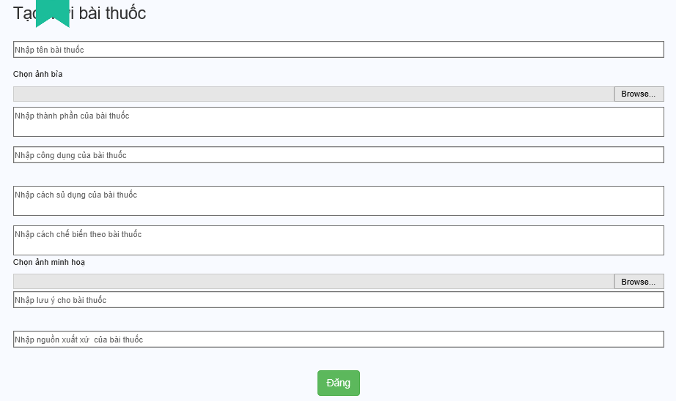

|  |  |  |  |  |  |  |  |
| --- | --- | --- | --- | --- | --- | --- | --- |
| No | Field name | Field name in Vietnamese | Type | Require | Mandatory | Max-Length | Description |
|  | Create new remedy | Tạo mới bài thuốc | Label |  | Y |  | Display text |
|  | Remedy | Tên cây thuốc | Text | Type | Y | 20 | Remedy name |
|  | Choose background | Chọn ảnh bìa | Button | Click | Y |  | Image of Remedy |
|  | Element | Nhập thành phần bài thuốc | Text | Type | Y |  | Remedy element |
|  | Utility | Nhập công dụng bài thuốc | Text | Type | Y |  | Remedy utility |
|  | Making | Nhập cách chế biến | Text | Type | Y |  | How to make |
|  | Choose example pictures | Chọn ảnh minh họa | Text | Type | Y |  | User choose pictures |
|  | Note | Nhập lưu ý cho bài thuốc | Text | Type | Y |  | User type note to use |
|  | The origin of remedy | Nhập nguồn gốc xuất xứ của bài thuốc | Text | Type | Y |  | User type the origin of remedy |
|  | Post | Đăng | Button | Click | Y |  | Đăng cây thuốc |

## Edit article

### Edit medicinal plant article

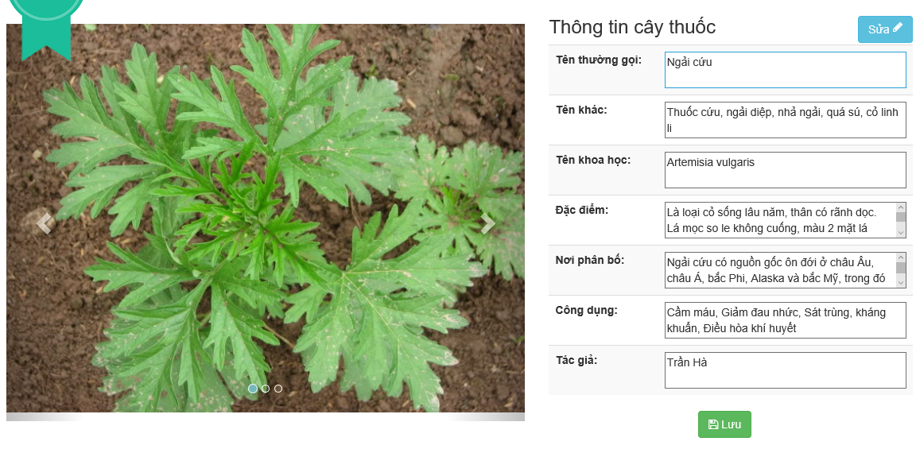

1. Edit medicinal plant article

|  |  |  |  |  |  |  |  |
| --- | --- | --- | --- | --- | --- | --- | --- |
| No | Field name | Field name in Vietnamese | Type | Require | Mandatory | Max-Length | Description |
| 1 | Picture | Ảnh | Image |  | Y |  | Show medicinal plant picture |
| 2 | Edit | Chỉnh sửa | Button | Click | Y |  | Click edit to edit medicinal article |
| 3 | Medicinal plant picture | Ảnh cây thuốc | Picture | Type | Y |  | Show plant picture |
| 4 | Name | Tên cây thuốc | Text | Type | Y | 8-20 | Show plant name |
| 5 | Other name | Tên khác | Text | Type | Y | 8-200 | Show other name |
| 6 | Science name | Tên khoa học | Text | Type | Y | 8-200 | Show science name |
| 7 | Description | Miêu tả | Text | Type | Y | 500 | Show plant shape |
| 8 | Characteristic | Đặc tính | Text | Type | Y | 500 | Show plant characteristic |
| 9 | Allocation place | Nơi trồng | Text | Type | N | 8-20 | Show allocation place |
| 10 | Utility | Công dụng | Text | Type | Y | 500 | Show plant utility |
| 11 | Save | Lưu | Button | Click | Y |  | User click save to update medicinal article |

1. Edit medicinal plant article

### Edit remedy article

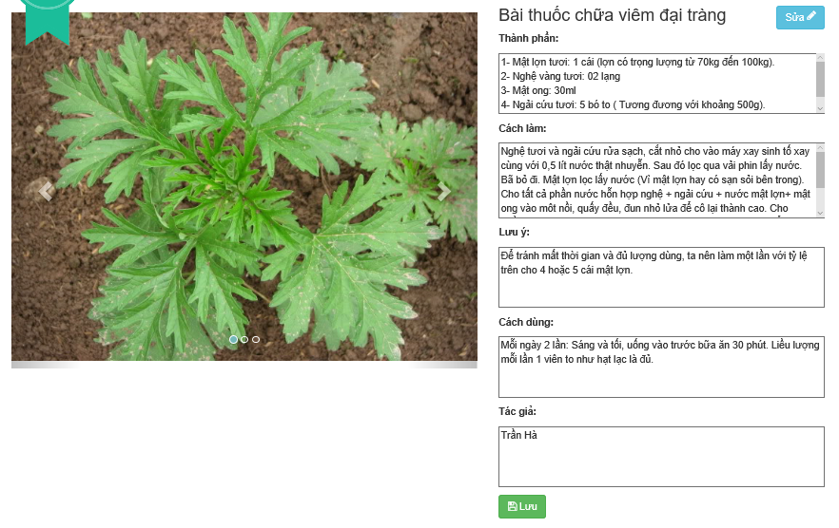

1. Edit remedy article

|  |  |  |  |  |  |  |  |
| --- | --- | --- | --- | --- | --- | --- | --- |
| No | Field name | Field name in Vietnamese | Type | Require | Mandatory | Max-Length | Description |
|  | Picture | Ảnh | Image |  | Y |  | Show remedy picture |
|  | Edit | Chỉnh sửa | Button | Click | Y |  | Click edit to edit medicinal article |
|  | Element | Thành phần | Text area | Type | Y | 500 | Element of remedy article |
|  | Making | Cách làm | Text area | Type | Y | 500 | Show how to make |
|  | Note | Chú ý | Text area | Type | Y | 500 | Note when using |
|  | How to use | Cách dùng | Text area | Type | Y | 500 | Show how to use |
|  | Author | Tác giả | Text area | Type | Y | 8-20 | Author of remedy article |
|  | Save | Lưu | Button | Click | Y |  | User click save to update medicinal article |

1. Edit remedy article table

## Profile

### User profile

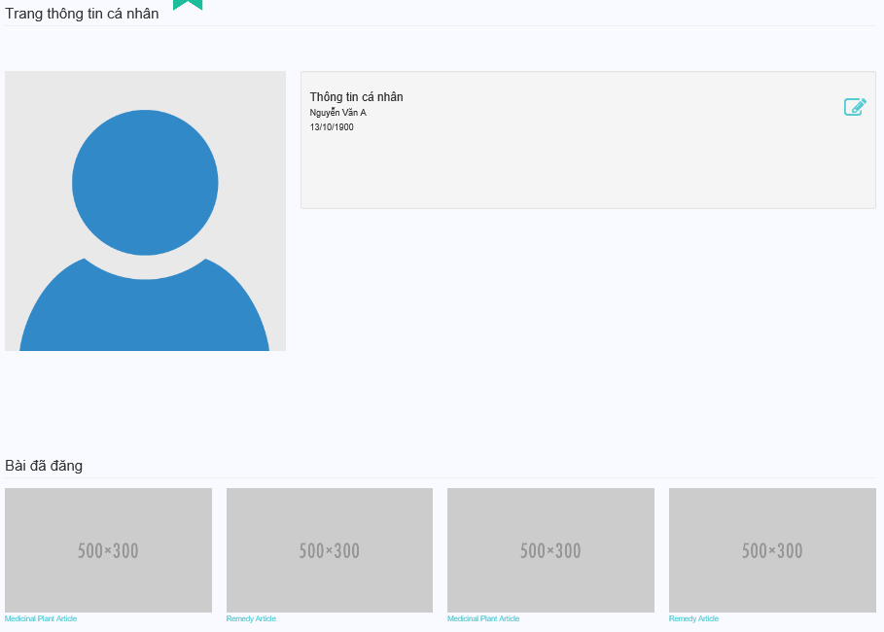

|  |  |  |  |  |  |  |  |
| --- | --- | --- | --- | --- | --- | --- | --- |
| No | Field name | Field name in Vietnamese | Type | Require | Mandatory | Max-Length | Description |
|  | Picture | Ảnh đại diện | Image |  | Y |  | Show remedy picture |
|  | User Infomation | Thông tin cá nhân | Label |  | Y |  | Display text |
|  | Edit | Chỉnh sửa | Button | Click | Y |  | Click edit button to edit user information |
|  | Full name | Họ tên | Text | Type | Y | 20 | User full name |
|  | Date of birth | Ngày tháng năm sinh | Text | Type | Y | 10 | User date of birth |
|  | Posted Articles | Bài đã đăng | Label |  | Y |  | Display text |
|  | Posted articles list | Danh sách các bài đã đăng |  |  | Y |  | Show posted articles list |

### Edit profile

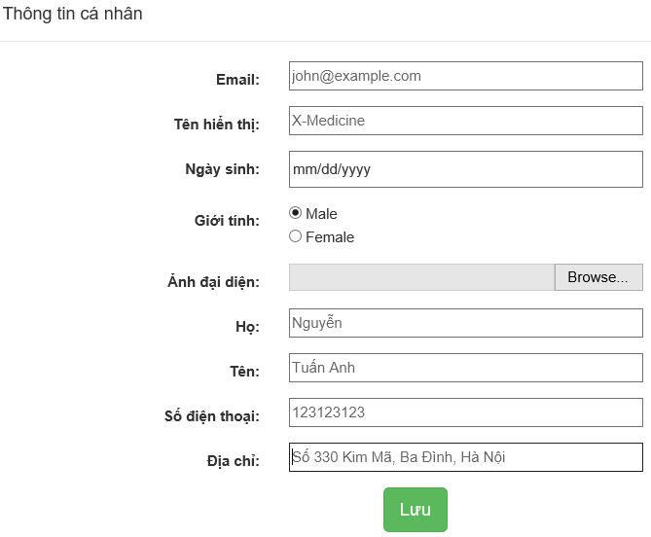

|  |  |  |  |  |  |  |  |
| --- | --- | --- | --- | --- | --- | --- | --- |
| No | Field name | Field name in Vietnamese | Type | Require | Mandatory | Max-Length | Description |
|  | User Information | Thông tin cá nhân | Label |  | Y |  | Display text |
|  | User name | Tên hiển thị | Text | Type | Y | 20 | User name |
|  | Date of birth | Ngày sinh | Radio | Click | Y | 10 | Date of birth |
|  | Gender | Giới tính | Text | Type | Y |  | Gender of user |
|  | Profile picture | Ảnh đại diện | Button | Click | Y |  | Profile picture |
|  | Last name | Họ | Text | Type | Y | 20 | Last name of user |
|  | First name | Tên | Text | Type | Y | 20 | First name of user |
|  | Phone | Số điện thoại | Text | Type | Y | 20 | Phone number of user |
|  | Address | Địa chỉ | Text | Type | Y | 50 | User address |

## Admin

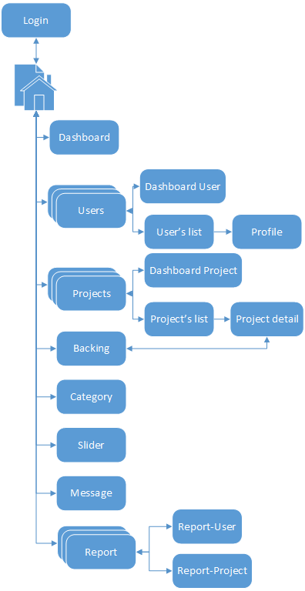

1. Admin screen flow

### Managing user

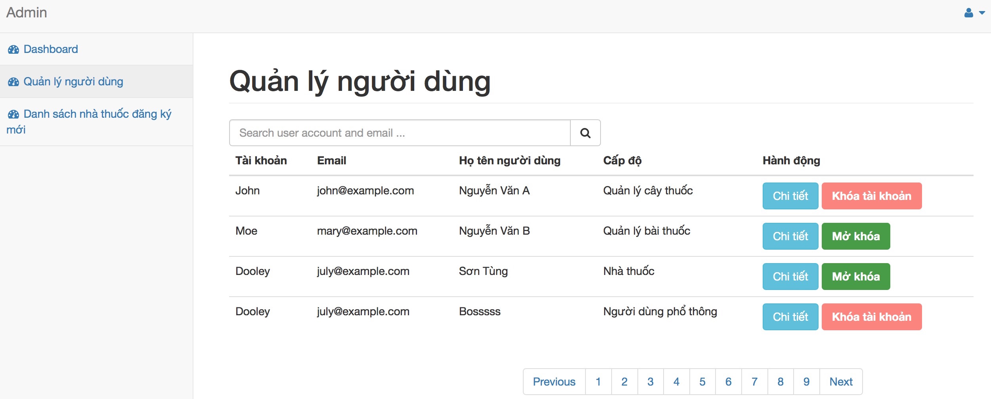

|  |  |  |  |  |  |  |  |
| --- | --- | --- | --- | --- | --- | --- | --- |
| No | Field name | Field name in Vietnamese | Type | Require | Mandatory | Max-Length | Description |
|  | Managing users | Quản lý người dùng | Label |  | Y |  | Display text |
|  | Search Box | Ô tìm kiếm | Text | Type | Y |  | Type user account or email to search |
|  | Search icon | Biểu tượng tìm kiếm | Button | Click | Y |  | Click to search user account |
|  | Account | Tài khoản | Text |  | Y |  | Show user account |
|  | Email | Địa chỉ hòm thư | Text |  | Y |  | Show user email |
|  | User’s full name | Họ và tên người dùng | Text |  | Y |  | Show user’s full name |
|  | Level | Cấp độ | Text |  | Y |  | Show user’s level |
|  | Action | Hành động | Text |  | Y |  | Show action: detail, lock, unlock account |
|  | Detail | Chi tiết | Button | Click | Y |  | Show detail |
|  | Lock account | Khoá tài khoản | Button | Click | Y |  | Lock user account |
|  | Unlock account | Mở khoá tài khoản | Button | Click | Y |  | Unlock user account |
|  | Pagging | Danh sách trang | Button | Click | Y |  | Moving between pages |

### Managing user information detail

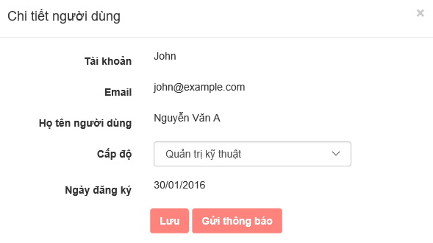

|  |  |  |  |  |  |  |  |
| --- | --- | --- | --- | --- | --- | --- | --- |
| No | Field name | Field name in Vietnamese | Type | Require | Mandatory | Max-Length | Description |
|  | User Information detail | Chi tiết người dùng | Label |  | Y |  | Show text |
|  | Account | Tài khoản | Text |  | Y |  | Show user account |
|  | Email | Địa chỉ hòm thư | Email |  | Y |  | Show user’s email |
|  | Full name | Họ và tên người dùng | Text |  | Y |  | Show user’s full name |
|  | Level | Cấp độ | Dropdown list | Click | Y |  | Show user’s level |
|  | Register date | Ngày đăng ký | Date |  | Y |  | Show register date |
|  | Save | Lưu | Button | Click | Y |  | Click to save |
|  | Send message | Gửi thông báo | Button | Click | Y |  | Click to send message to this account |
|  | Close | Đóng | Button | Click | Y |  | Click to close this modal |

### New registered herb medicine store list

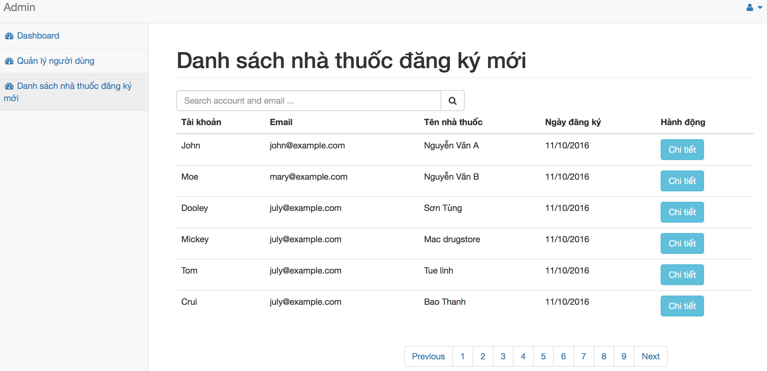

|  |  |  |  |  |  |  |  |
| --- | --- | --- | --- | --- | --- | --- | --- |
| No | Field name | Field name in Vietnamese | Type | Require | Mandatory | Max-Length | Description |
|  | Managing users | Quản lý người dùng | Label |  | Y |  | Display text |
|  | Search Box | Ô tìm kiếm | Text | Type | Y |  | Type user account or email to search |
|  | Search icon | Biểu tượng tìm kiếm | Button | Click | Y |  | Click to search user account |
|  | Account | Tài khoản | Text |  | Y |  | Show user account |
|  | Email | Địa chỉ hòm thư | Text |  | Y |  | Show user email |
|  | Herb medicine store | Tên nhà thuốc | Text |  | Y |  | Show herb medicine store name |
|  | Register date | Ngày đăng ký | Date |  | Y |  | Show register date of store |
|  | Action | Hành động | Text |  | Y |  | Show action |
|  | Detail | Chi tiết | Button | Click | Y |  | Click to show detail |
|  | Pagging | Danh sách trang | Button | Click | Y |  | Moving pages |

### New registered herb medicine store detail

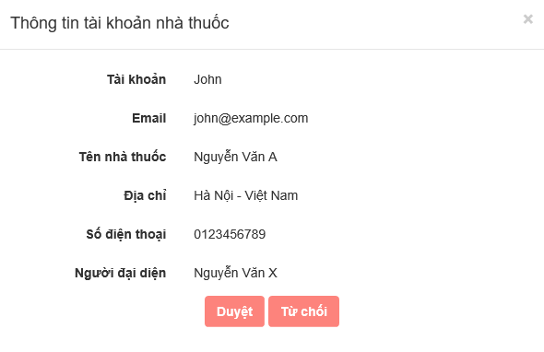

|  |  |  |  |  |  |  |  |
| --- | --- | --- | --- | --- | --- | --- | --- |
| No | Field name | Field name in Vietnamese | Type | Require | Mandatory | Max-Length | Description |
|  | Herb medicine store account information | Thông tin tài khoản nhà thuốc | Label |  | Y |  | Display text |
|  | Account | Tài khoản | Text |  | Y |  | Show herb medicine store account |
|  | Email | Địa chỉ hòm thư | Text |  | Y |  | Show herb medicine store email |
|  | Herb medicine store name | Tên nhà thuốc | Text |  | Y |  | Show herb medicine store name |
|  | Address | Địa chỉ | Text |  | Y |  | Show herb medicine store address |
|  | Phone | Số điện thoại | Text |  | Y |  | Show herb medicine store phone |
|  | Representative | Người đại diện | Text |  | Y |  | Show representative name |
|  | Approve | Duyệt | Button | Click | Y |  | Click to approve account |
|  | Ignore | Từ chối | Button | Click | Y |  | Click to ignore account |

## Mod